**Advanced Network Security**



**Assignment – Sheldon1**

Student Name: P. Anojithan

Student Number: MS19814766

Course: M.Sc. Information Technology specialization in Cyber Security

**Introduction**

This assignment has been done to test mid-level experience in Assembly Language. Here I used Kali Linux to do the practical. I have completed this report with the screenshots I have taken during the lab.

Objective of the lab is to diffuse the bomb by code which has six phases.

**Procedure**

Step 1: Navigate the file and run the file.

./schldon1

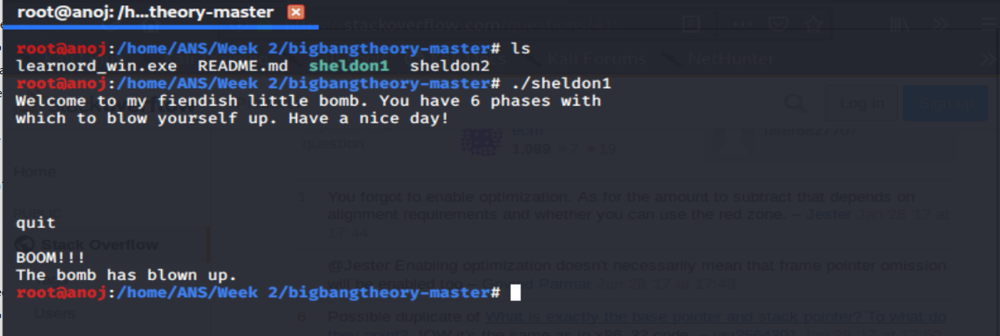

Step 2: Opened the file using gdb.

gdb sheldon1

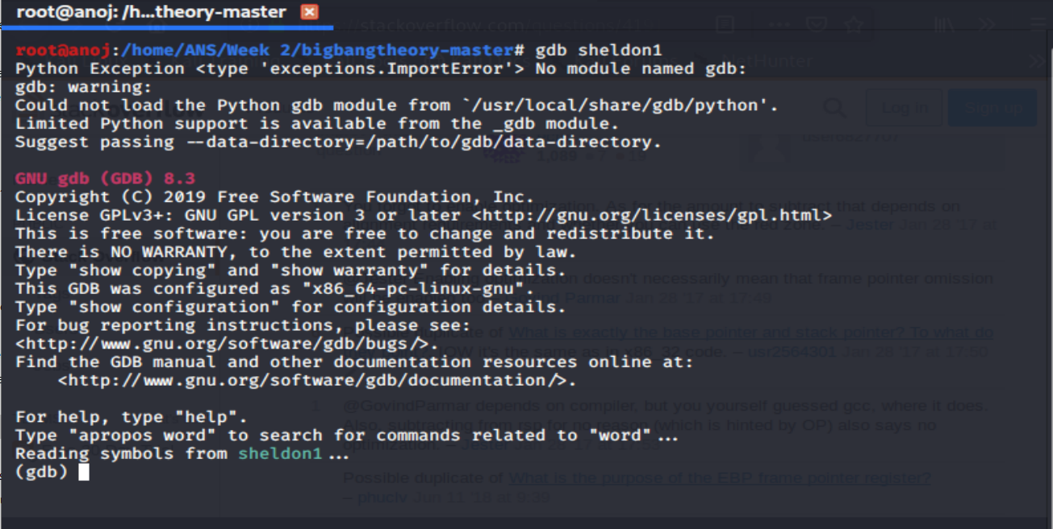

Step 3: dissembled the main function.

disass main

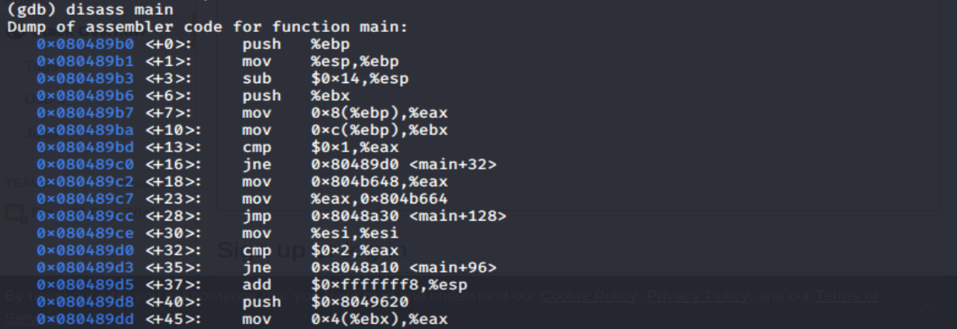

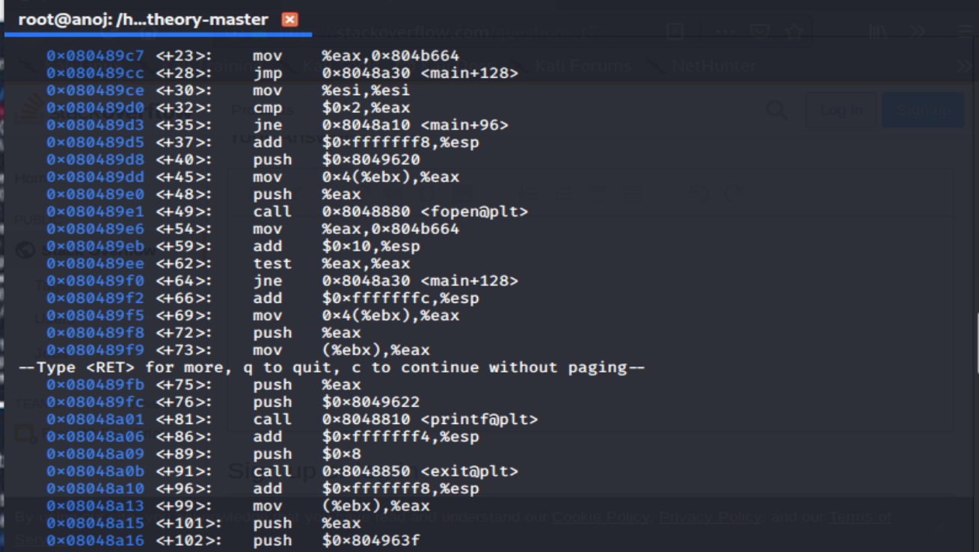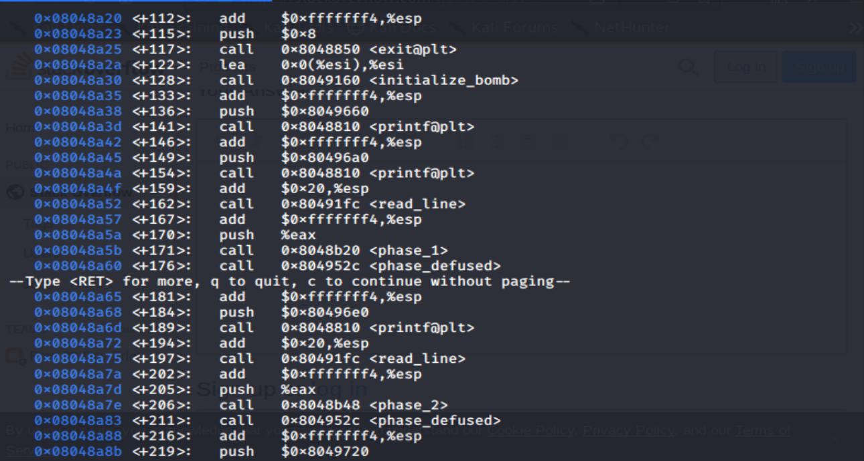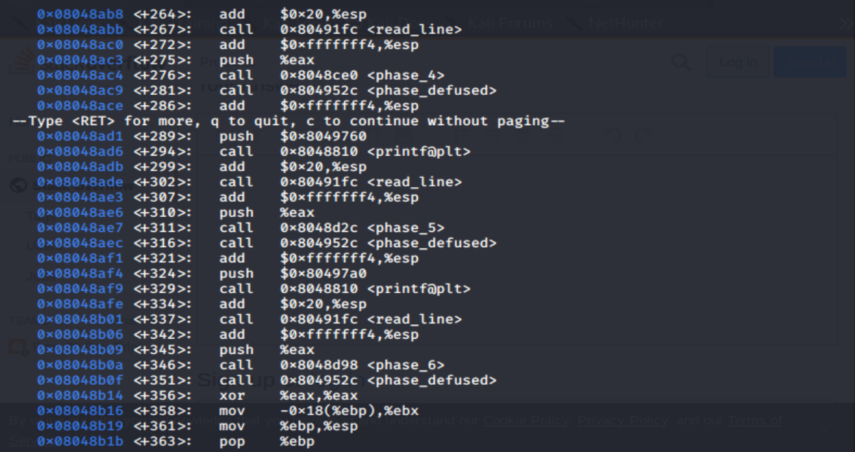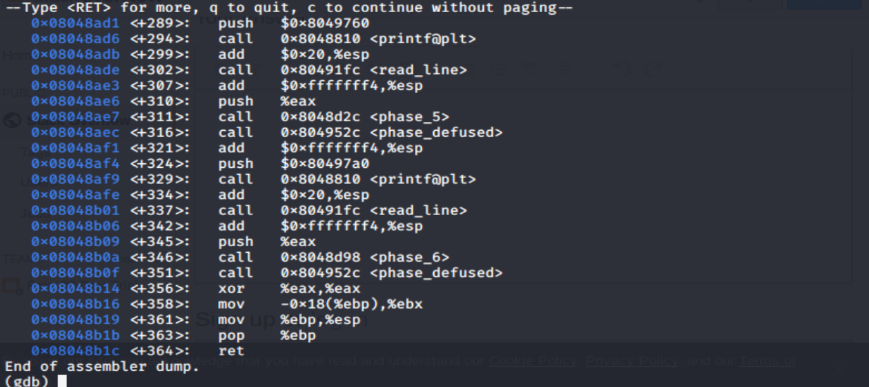

After disassembled the main, its visible there are 6 phases involved namely, Phase_1, Phase_2, Phase_3, Phase_4, Phase_5 and Phase_6.

Step 4: Disassembled phase_1

disass Phase_1

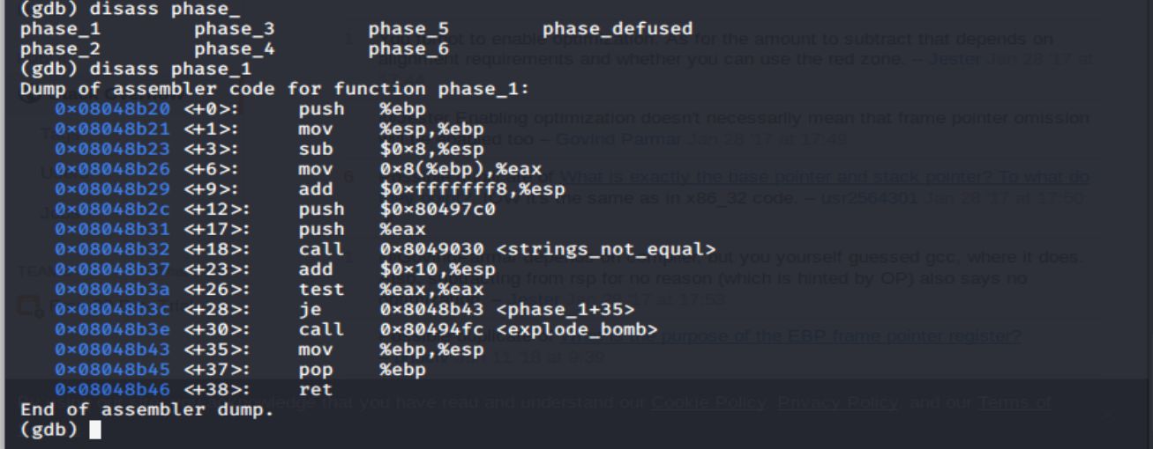

Step 5: checked for string values.

x/s 0x80497c0

The string reviled. It was “Public speaking is very easy.”

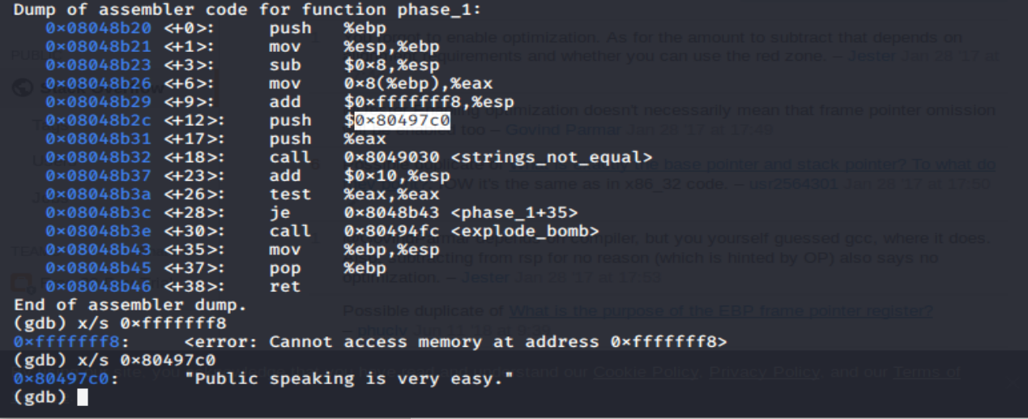

Step 6: Phase 1 diffused

Run the file sheldon1 (./sheldon1)and pasted the text retrieved from the phase 1.

